

**American International University- Bangladesh**

**COE 3103: DATA COMMUNICATION**

**Final Lab Report 05**

**Spring 2021-2022**

**Section: I**

**Date: 29/03/2022**

**Submitted by, Group 03**

|  |  |
| --- | --- |
| Student Name | Student Id |
| Rahman, Sheikh Talha Jubayer | 19-41468-3 |
| Shifat, Mahabub Hasan | 19-41460-3 |
| Hasan, Sayeed | 19-41005-2 |
| Islam, Hasan Sanjry | 19-39589-1 |
| Durjoy, Md. Badrul Alam | 18-39248-3 |

**Tasks**

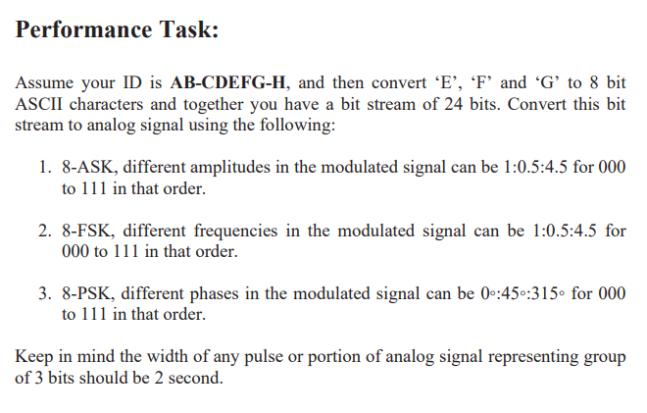

**Solution of Performance Task (1)**

%ID: 19-41468-3

%E = 4 = (ASCII) 52 = (BIN) 00110100

%F = 6 = (ASCII) 54 = (BIN) 00110110

%G = 8 = (ASCII) 56 = (BIN) 00111000

x = [0 0 1 1 0 1 0 0 0 0 1 1 0 1 1 0 0 0 1 1 1 0 0 0]; %input signal

am = 1:0.5:4.5; %amplitudes

nx = size(x,2); %number of bits in input signal

i=1; %first index of every three bits

j=0; %time index of a signal element

while i<nx-1 %until first index of last three bits

t = j:0.001:j+2; %time of a signal element in duration of 2 seconds

if x(i)==0 && x(i+1)==0 && x(i+2)==0 %when three bits are 000

ask = as(1)*sin(2*pi*t); %changes the amplitudes, phase 0, frequency 1

elseif x(i)==0 && x(i+1)==0 && x(i+2)==1 %when three bits are 001

ask = as(2)*sin(2*pi*t);

elseif x(i)==0 && x(i+1)==1 && x(i+2)==0 %when three bits are 010

ask = as(3)*sin(2*pi*t);

elseif x(i)==0 && x(i+1)==1 && x(i+2)==1 %when three bits are 011

ask = as(4)*sin(2*pi*t);

elseif x(i)==1 && x(i+1)==0 && x(i+2)==0 %when three bits are 100

ask = as(5)*sin(2*pi*t);

elseif x(i)==1 && x(i+1)==0 && x(i+2)==1 %when three bits are 101

ask = as(6)*sin(2*pi*t);

elseif x(i)==1 && x(i+1)==1 && x(i+2)==0 %when three bits are 110

ask = as(7)*sin(2*pi*t);

else %when three bits are 111

ask = as(8)*sin(2*pi*t);

end

i=i+3; %index of next three bits

j=j+2; %time index of next signal element

plot(t,ask);

hold on;

grid on;

axis([0 16 -4.5 4.5]);

title('Amplitude Shift Key');

xlabel('Time (s)');

ylabel('Amplitude');

end



**Solution of Performance Task (2)**

%ID: 19-41468-3

%E = 4 = (ASCII) 52 = (BIN) 00110100

%F = 6 = (ASCII) 54 = (BIN) 00110110

%G = 8 = (ASCII) 56 = (BIN) 00111000

x = [0 0 1 1 0 1 0 0 0 0 1 1 0 1 1 0 0 0 1 1 1 0 0 0]; %input signal

fs = 1:0.5:4.5; %frequensies

nx = size(x,2); %number of bits in input signal

i=1; %first index of every three bits

j=0; %time index of a signal element

while i<nx-1 %until first index of last three bits

t = j:0.001:j+2; %time of a signal element in duration of 2 seconds

if x(i)==0 && x(i+1)==0 && x(i+2)==0 %when three bits are 000

fsk = sin(2*pi*fs(1)*t); %changes the frequescies, amplitued 1, phase 0

elseif x(i)==0 && x(i+1)==0 && x(i+2)==1 %when three bits are 001

fsk = sin(2*pi*fs(2)*t);

elseif x(i)==0 && x(i+1)==1 && x(i+2)==0 %when three bits are 010

fsk = sin(2*pi*fs(3)*t);

elseif x(i)==0 && x(i+1)==1 && x(i+2)==1 %when three bits are 011

fsk = sin(2*pi*fs(4)*t);

elseif x(i)==1 && x(i+1)==0 && x(i+2)==0 %when three bits are 100

fsk = sin(2*pi*fs(5)*t);

elseif x(i)==1 && x(i+1)==0 && x(i+2)==1 %when three bits are 101

fsk = sin(2*pi*fs(6)*t);

elseif x(i)==1 && x(i+1)==1 && x(i+2)==0 %when three bits are 110

fsk = sin(2*pi*fs(7)*t);

else %when three bits are 111

fsk = sin(2*pi*fs(8)*t);

end

i=i+3; %index of next three bits

j=j+2; %time index of next signal element

plot(t,fsk);

hold on;

grid on;

axis([0 16 -1 1]);

title('Frequency Shift Key');

xlabel('Time (s)');

ylabel('Amplitude');

end



**Solution of Performance Task (3)**

%ID: 19-41468-3

%E = 4 = (ASCII) 52 = (BIN) 00110100

%F = 6 = (ASCII) 54 = (BIN) 00110110

%G = 8 = (ASCII) 56 = (BIN) 00111000

x = [0 0 1 1 0 1 0 0 0 0 1 1 0 1 1 0 0 0 1 1 1 0 0 0]; %input signal

ps = 0:pi/4:7*(pi/4); %phases

nx = size(x,2); %number of bits in input signal

i=1; %first index of every three bits

j=0; %time index of a signal element

while i<nx-1 %until first index of last three bits

t = j:0.001:j+2; %time of a signal element in duration of 2 seconds

if x(i)==0 && x(i+1)==0 && x(i+2)==0 %when three bits are 000

psk = sin(2*pi*t+ps(1)); %changes the phases, amplitued 1, frequency 1

elseif x(i)==0 && x(i+1)==0 && x(i+2)==1 %when three bits are 001

psk = sin(2*pi*t+ps(2));

elseif x(i)==0 && x(i+1)==1 && x(i+2)==0 %when three bits are 010

psk = sin(2*pi*t+ps(3));

elseif x(i)==0 && x(i+1)==1 && x(i+2)==1 %when three bits are 011

psk = sin(2*pi*t+ps(4));

elseif x(i)==1 && x(i+1)==0 && x(i+2)==0 %when three bits are 100

psk = sin(2*pi*t+ps(5));

elseif x(i)==1 && x(i+1)==0 && x(i+2)==1 %when three bits are 101

psk = sin(2*pi*t+ps(6));

elseif x(i)==1 && x(i+1)==1 && x(i+2)==0 %when three bits are 110

psk = sin(2*pi*t+ps(7));

else %when three bits are 111

psk = sin(2*pi*t+ps(8));

end

i=i+3; %index of next three bits

j=j+2; %time index of next signal element

plot(t,psk);

hold on;

grid on;

axis([0 16 -1 1]);

title('Phase Shift Key');

xlabel('Time (s)');

ylabel('Amplitude');

end

